SURVEY ZONE



KAWALJEET KAUR-300774451

NISHA DHANWANI-300773598

NAVDEEP KAUR GILL-300772906

TABLE OF CONTENT

|  |  |  |
| --- | --- | --- |
| S.NO | TOPICS | PAGE NO |
| 1 | Description of site | 1-2 |
| 2 | Wireframe section | 3-5 |
| 3 | Screen capture section | 6-9 |
| 4 | Potential Future  Functionality | 10s |

DESCRIPTION OF SITE

This is a survey site contains the students survey. This includes the login section which is for those who are already member of this survey. The next includes the sign up for those who are not member of survey but want to make a survey, so they have to first of all sign up and fill up the form which contains the fields like name, password, and username, date of birth, address, cell number and zip code. When a person registers himself by filling the form then he or she can make the survey. The survey page includes the question section where a person can make the survey and creates the question. This site have link with database SQL. The proper connection makes to the SQL by creating the table like user table, question table, user response table, and question type table. The github page is a repository which contains all the project files. This is secure website which contains the proper security functions. The html, cascading style sheet and JavaScript all these technologies are used to create this site.

* HOME PAGE: In the home page, there is a form which includes the username and password in which user can login to the survey page. It also includes the signup for those who are not member of that survey.
* SIGN UP PAGE: This page includes the different fields like name, password, username, date of birth, address, zip code, cell number.
* RESPONSE SURVEY: This page includes the survey questions that are stored in the database.

WIREFRAME SECTION

HOME PAGE:

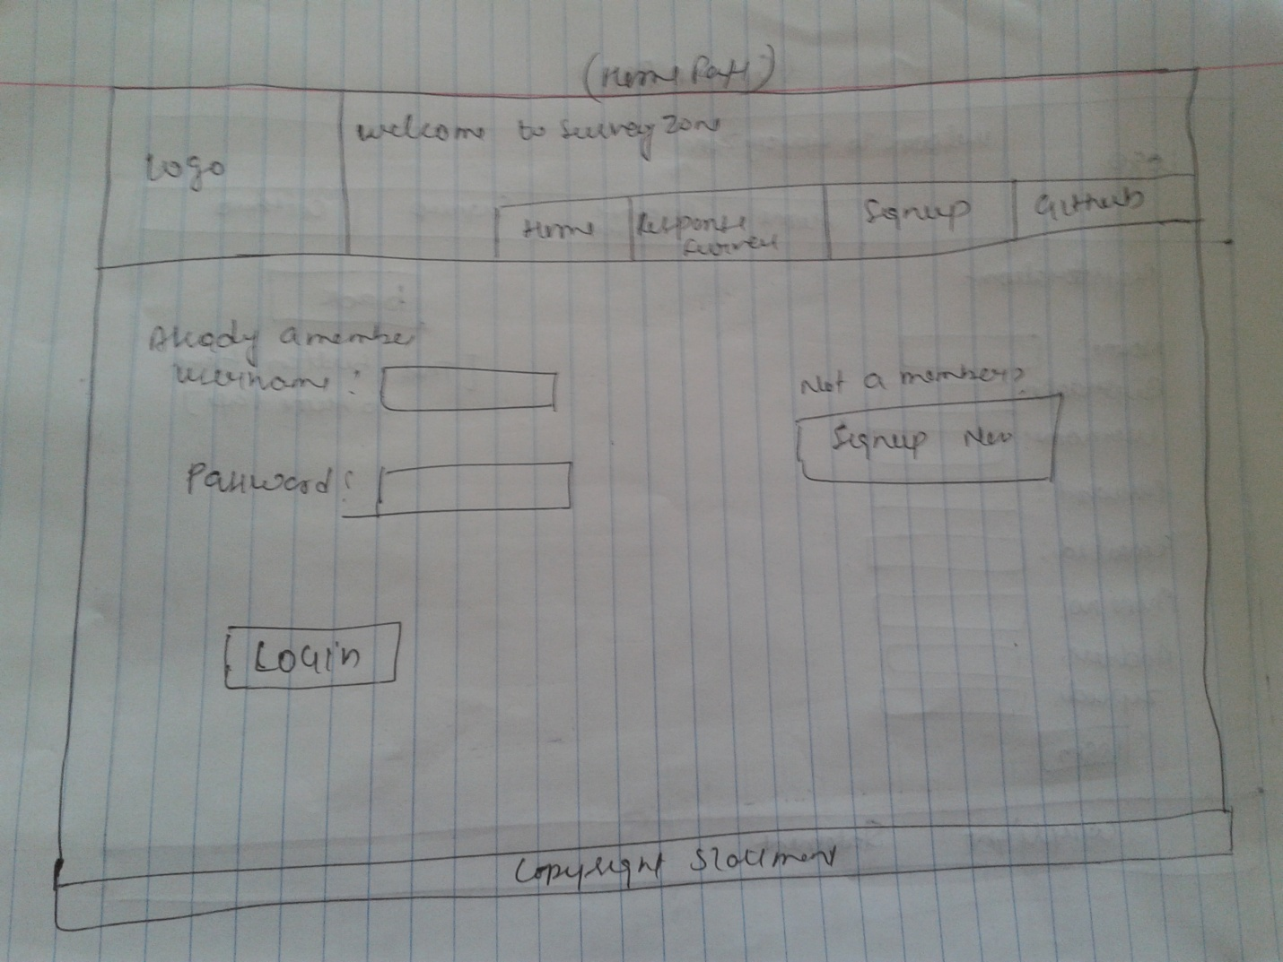

SIGNUP PAGE:

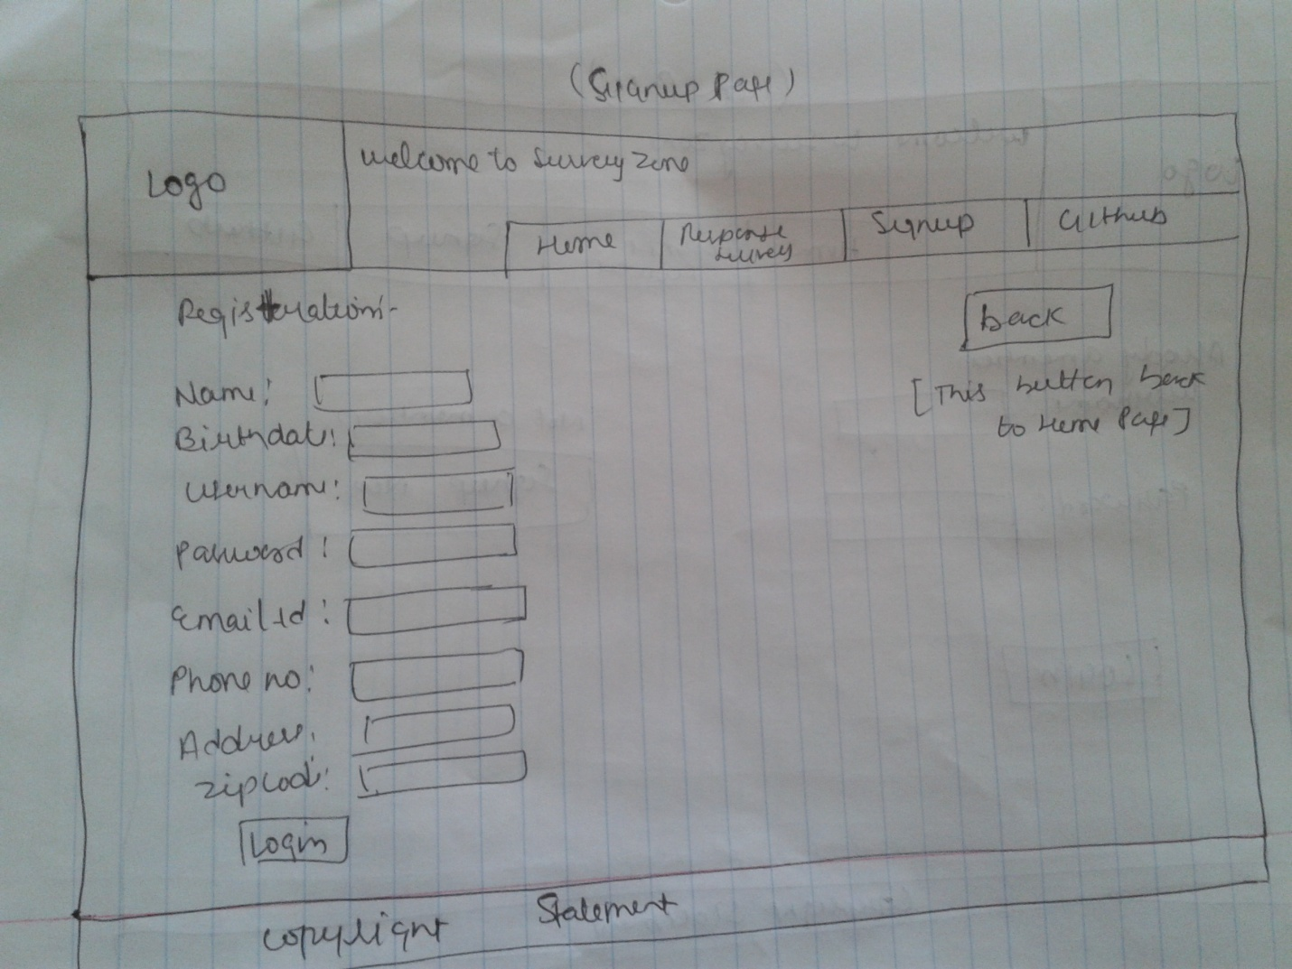

SURVE Y RESPONSE PAGE:

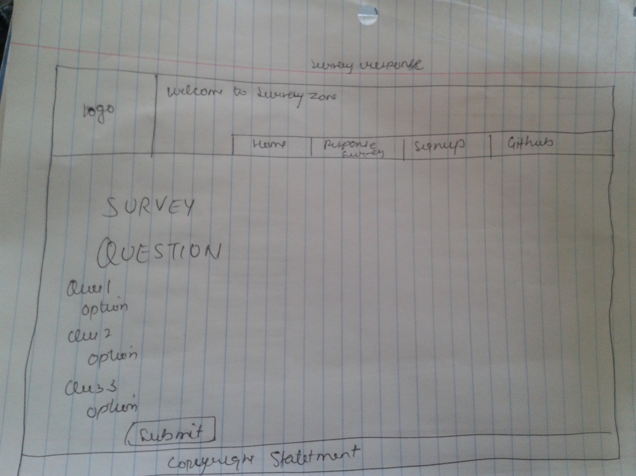

SCREEN CAPTURE SECTION

Home page:

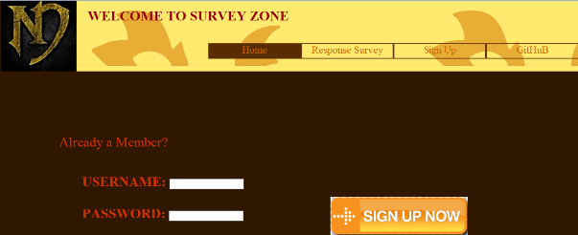

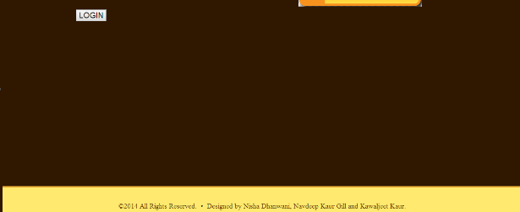

Sign up page:

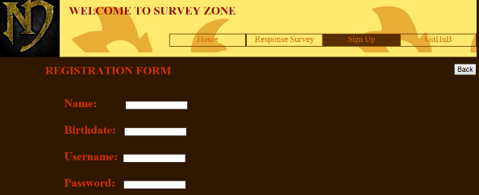

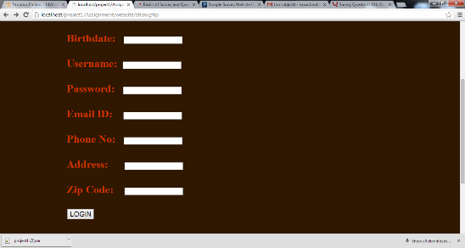

Response survey:

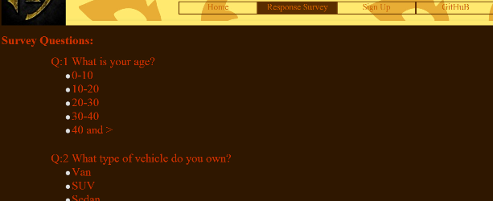

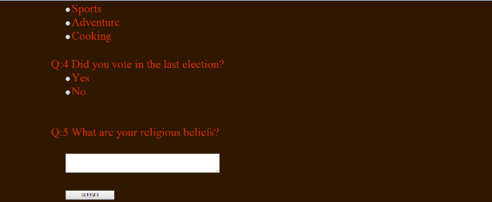



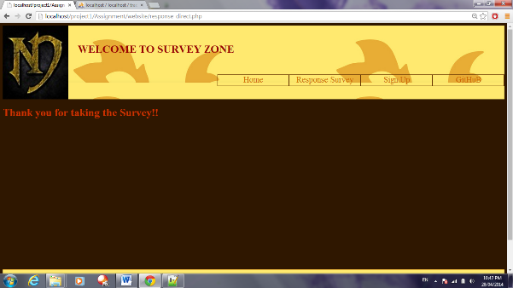

FUTURE FUNCTIONALITY

* In the future we want to add the survey topic in response survey like when user enter his or her topic of his own choice, he or she will redirect to a particular page which contains the survey question related to that topic.
* A particular user can make the survey. We want to make the site and database more secure by making the password hashed. When user enters his or her password that is stored in hashed manner so no one is able to hack the password.